Lab Assignment 7: Form Page

Due Week 7 Deliverables: One (1) Web page and one (1) Cascading Style Sheet (.css)

Complete the weekly lab based on the following:

- Write the code for each lab assignment.
- The code is to be submitted in a single compressed folder (zip file) to the online course shell. The file must contain all .htm files, along with any other files that may be necessary for your project to run (ex: text files, images, etc.).
- When saving the file, it should be saved as Lab_#7_Maysonet_W.htm.
- Any and all written answers must be entered into the online course shell with the submission of the attached lab assignment.

Follow the directions below to complete Lab Assignment 7:

Note: The CGI bin script does not work for us because we do not have a server to run it on. Therefore, we will use the code listed here instead of the .js files.

In order to have the Submit and Cancel buttons clear the fields, put this line in your code:

After your <head> tag:
<meta charset="utf-8" />
And this line after your <body> tag:
<form id='sampleform' method='post' action='' >

The above code will help the fields clear without taking you away from the page.

- Re-create the Web page with a form, and create a heading that states your name and the purpose of the page. Example: “Mary Smith’s Sample Form Page” states the purpose of the page.
- Create an entry field for:
  - “Name”.
  - “Street Address”.
  - “City”.
  - “State (abbr.)”.
- Create the formstxt.css sheet and apply it to the page.
- Enter your city and state as the default values for the fields.
- Use local tags on the page to override the .ccs and set the size of the font for “Student Information” to 16 pt.
- Create the “Submit” and “Cancel” buttons.
- Validate that the buttons clear the name and street address when selected.

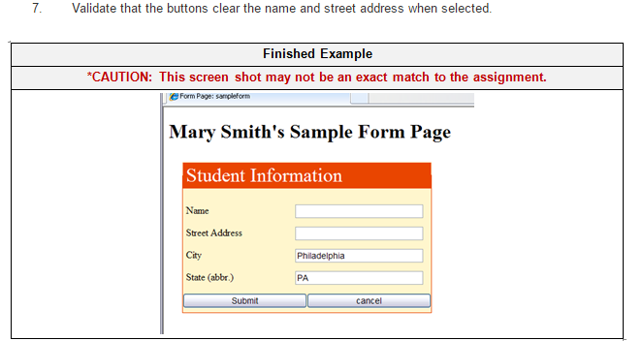

Lab Assignment 7: Form Page
Criteria | 0 points  Unacceptable | 2 points  Developing | 4 points  Sufficient
1. Re-create the Web page with a form, and create a heading that states your name and the purpose of the page. Example: “Mary Smith’s Sample Form Page” states the purpose of the page. | Did not complete. | Completed with errors. | Completed correctly.
2a. Create an entry field for “Name”. | Did not complete. | Completed with errors. | Completed correctly.
2b. Create an entry field for “Street Address”. | Did not complete. | Completed with errors. | Completed correctly.
2c. Create an entry field for “City”. | Did not complete. | Completed with errors. | Completed correctly.
2d. Create an entry field for “State (abbr.)”. | Did not complete. | Completed with errors. | Completed correctly.
3. Create the formstxt.css sheet and apply it to the page. | Did not complete. | Completed with errors. | Completed correctly.
4. Enter your city and state as the default values for the fields. | Did not complete. | Completed with errors. | Completed correctly.
5. Use local tags on the page to over-ride the .ccs and set the size of the font for “Student Information” to 16 pt. | Did not complete. | Completed with errors. | Completed correctly.
6. Create the “ Submit” and “Cancel” buttons. | Did not complete. | Completed with errors. | Completed correctly.
7. Validate that the buttons clear the name and street address when selected. | Did not complete. | Completed with errors. | Completed correctly.

